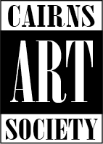

Cairns Art Society Inc
Annual General Meeting Notice 2023

The Cairns Art Society Inc. will meet to convene their Annual General Meeting as follows:

Date: Thursday February 29th Time: 6pm
Venue: Artists@Work Address: 51 Lake Street, Cairns

*****Only financial members may vote or be elected at this meeting.*****

Agenda

Chair:
Apologies
Minutes of 2022 Annual General Meeting read
Acceptance of the minutes
President’s final report
Acceptance of the report
Treasurer’s final report
Acceptance of the report
Auditor’s report
Acceptance of the report
All committee positions declared vacant
Opening of the voting
Nominations for office bearers read
Votes for the office bearers counted and announced
Nominations for general committee members (these may be taken from the floor on the day).
Votes for general committee members counted and announced
Welcome to the new committee
New president and committee to take the chair
Appointment of an auditor
General business
Close of business

